**Estonia Erasmus+ November 2022 Xántus János Gimnázium**

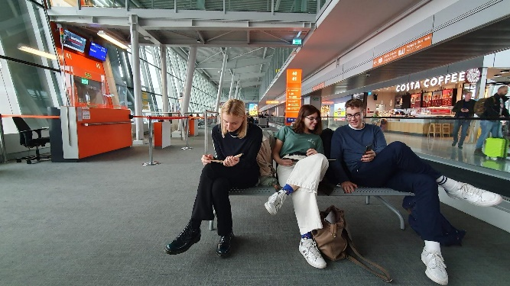

12th of November 2022

We met on Saturday at the Budapest Airport at 7:30, everyone was already excited. Our flight to Warsaw took around 1 hour which is definitely short in terms of flights. We spent approximately 3 hours at the airport in Warsaw. There Frani tried chimichurri beef, a delightsome Bolivian dish. We could look over our presentation about Hungary for the Estonian students. We arrived in Tallinn at 5 PM. We decided to go by train to Tartu which took 2,5 hours. We met our host families at the train station in Tartu.

13th of November 2022

On Sunday, on our first day in Estonia, we were given the chance to get to know our host families and the Tartumaa region.

Franciska Sunday:

Liisi gave me a tour around Tartu. It was interesting to see everything from her perspective. Then we went back to their apartment and cooked dinner. During the evening we watched the Hungarian film “Mindenki” and listened to Estonian and Hungarian music. She introduced me to their famous and anticipated song festival, Laulupidu. She and her family were really hospitable and welcoming toward me, which I’m really grateful for.

Viktor Sunday:

On Sunday I had the chance to attend a real Estonian Lutheran mass. Obviously, I could not understand a word, but the family was really helpful and translated the ceremony. After that, I could participate in Kaisa's family gatherings. They treated me kindly and were curious about the “Hungarian exchange student”. We were served a tremendous amount of food. After the meal, the younger ones showed me around and introduced me to the authentic Estonian village lifestyle, where the father was actually raised. When we finished, Kaisa's Dad brought us to the bank of the river, which was located next to the Russian border. For me, it was a tiny bit of a scary experience because before that I have never been so close to the dreaded country. On that day I could have a little insight into the division of national minorities in Estonia based on the narratives of the family members. I feel honored to be a part of their community even for one day.

András Sunday:

As Nastja had a dancing competition Saturday evening she was not able to meet me at the train station. However, we had the opportunity to spend the whole next day together. In the morning we had breakfast together which was made with the traditional Hungarian paprika to spice it up. After it, I and Nastja went to walk their dog Motja. She also showed me the bank of the nearest river, the Emajögi. After lunch, she had to prepare for her test the next day so I could have a look at the Estonian Curriculum as well.

Csilla Sunday:

My exchange student, Anna, told me about how Estonians are really close to nature and on Sunday they took me hiking. I saw the famous wetlands of Estonia, and they even mentioned how lucky we were as the sun was shining and it was around 12 degrees, which is definitely not common in November. Hence the good weather, we took our precious time in the wild and spent 2 hours there. Afterwards, we went to have lunch with her family and they got to know me better. I told them about my life and about Hungary and they were fascinated by the cultural differences. Then, her dad took us to the shopping centre and we did a little grocery shopping. Anna is vegan, so we had dietary differences and in order to solve this, I was told to buy everything I’d want to eat for the week. When we arrived home, Anna started preparing for the food court and I relaxed a bit, read, and studied a bit.

Luca Sunday:

Today Karolina took me to the AHHAA science center. This museum offers several fascinating experiments even for those who are not fans of science.

In the afternoon I went hiking with Karolina and her mother to the woods. After approximately 40 minutes of driving, we arrived at a common hike destination. I'm still amazed by the natural treasures of Estonia. In the evening we had dinner at Karolina's favorite restaurant called Kolm Tilli. Later we returned home and played some card games together.

14th of November 2022

We went to the Hugo Treffner Gymnasium for the first time on Monday. Kaisa and the other Estonians introduced us to their school. After the tour around the institution, we played fun warm-up games conducted by Karolina in order to get familiar with each other. Then two teams were created for the project work, whose topic was the integration of minorities in Estonia. We had some time to brainstorm a few ideas and then went to the Institution of Baltic studies, where Kirill Jurkov gave us the insightful lecture “How do you manage a country inhabited by many different nationalities?”. After the filling lunch at the school canteen, we listened to a presentation about Estonia given by Anna and learned a lot of new and intriguing facts about the Estonian state and people. Then students prepared their meals for the Food court. Unfortunately because of our long journey to Tartu, we couldn’t make anything special, only szaloncukor, winter salami, and goose liver pathé but the Estonian students still loved them. We tried meals from their cuisines of course, such as ham rolls, fish sandwiches, kamma, breadsoup, the homemade pickles of Aare, and kringel. All of these dishes were really tasty and peculiar for us. After the organized programmes 4 of us stayed in the school to practice our presentation about Hungary and Xántus János Bilingual Secondary School. In the evening we hung out together and went to the shopping mall. Two Estonian students were also with us. Sadly the others couldn’t join due to sports, family, or school-related issues but we still managed to have a fun night. 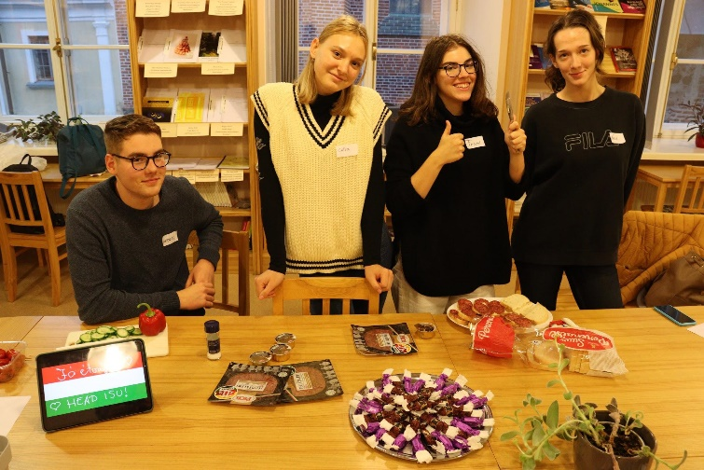

15th of November 2022

On this day the main goal was to get a deep understanding of the national minorities in Estonia, especially from the point of view of the Russian population. In order to do so we went to the Pushkin Russian-speaking school. We were told that in Estonia even the Russian schools must teach relying on the Estonian National Curriculum- so they are obliged to teach most of the subjects in Estonian, not in Russian. We formed groups of 3 people: an Estonian, a Hungarian, and finally a Russian student. Since 1991, when Estonia gained its independence, most of the integration projects have failed, so we were focused on the possible solutions. It was interesting to hear that despite the expectations the Russian students can speak Estonian well. In the beginning, it was such a challenge to get to the main point of the Russo-Estonian coexistence and talk about a deep and sensitive topic but I assume that we could cope with it. There I(Andras) could even present our school to the headmaster in Russian. 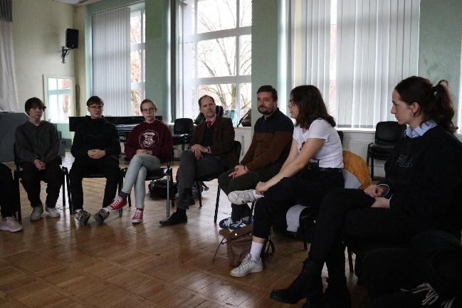

After lunch we held our presentation about Hungary- which contained details of our folk dance, holidays and, finally, Csilla talked about Hungarian history. It was a great feeling to see Estonians being interested in our culture and history. We shortly introduced the Xántus János Gymnasium and our school system. Overall we feel that our speech had a positive impact on the Estonians. We were happy to answer the Hungary-related questions of the Estonian students.

16th of November 2022

This day started with a little warm-up report made by the DW (Deutsche Welle) about the Russian community in Narva and their reaction in terms of the recent Russian invasion of the Ukraine. These sources made our job even more complicated because we gained little insight into ordinary people’s points of view and the impacts that influence their actions. These are factors they cannot help with, so we had to choose wisely our approach to the issue to find a solution that seems to be the most widely acceptable. After this remarkable experience, we could participate in a real Estonian English lesson, which was captivating. Their lessons last longer than ours (they are approximately 90 minutes). The English teacher tried to involve us in the work and we could share our opinions concerning the phenomena of crimes in both countries. Once we finished, we had the chance to play Pétanque. Most of us tried this game for the first time, and I would say none of us has got negative feelings regarding this cute team-building activity. After this amazing experience, we had the opportunity to immerse ourselves in our project work for one and a half hours. It was always a pleasure to consider every possible solution with my enthusiastic Hungarian and Estonian teammates. Clearly, we became hungry after this, so we continued our journey in the canteen, where next to all the delicious dishes we were served with the iconic potatoes as well. Eventually, our next destination was the well-appreciated Estonian National Museum. We were introduced to the Estonian heritage from contemporary events back to the early days of this unique nation. For me, the events in connection with the collapse of the Soviet Union were really powerful, and I strongly believe that we Hungarians should also remember how valuable freedom really is, by remembering the tragic losses in times of dictatorships. Our guide was a very sensible lady, who could grab our attention with her educative speeches and great sense of humor. Even though the guide lasted only an hour we spent our time in the museum till closing, and nobody regrets it.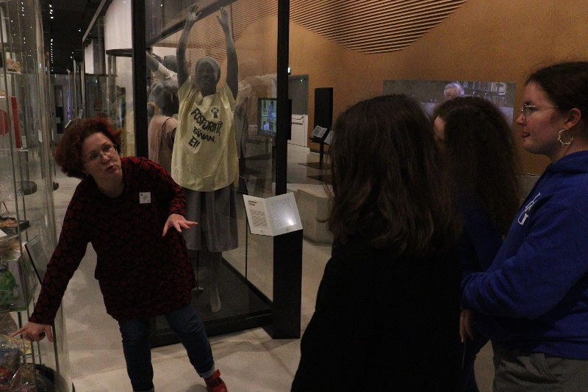

17th of November:

Today we started with a documentary about the history of Estonia. We found it interesting and some scenes got us emotional. In order to get to know Tartu a bit more, the Estonian students planned a city game. The goal was to walk around and with the help of a map and the Estonian students discover clues and answer questions. It was freezing, but the Estonians weren’t bothered by the cold, unlike the Hungarians who only experience low temperatures like this in January. We managed to complete the task in two separate groups and had a wonderful time. During the game, we explored all the artworks of street art in Tartu. We grabbed a coffee and some pastry, then headed back to school where we could warm up a little bit. We had ten minutes before we went back to the town center again and we were introduced to the history of the town a bit. We also experienced the very first snow of the year. We were given some free time to buy souvenirs before having to go back to school to have lunch. This day was a tiny bit stressful for all of us since we had to present our project to the students who were interested in the topic. Performing in front of several people in English was not an easy job, but we managed to give an insight on the topic to everyone who came to see us. We had great points and successfully came up with solutions to solve the chosen problem regarding ethnic minorities in Estonia. To celebrate, we went to the AHHAA, which was similar to the Palace of Wonders in Budapest. We spent an hour there, having fun and experimenting with amusing scientific games. 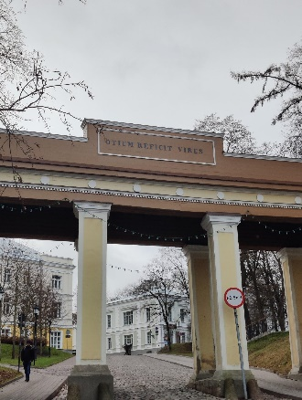

18th of November

On our last day, we went on a trip to the Northern-eastern part of Estonia. First, we visited the Pukhitsa Convent. It was something special to see a Russian-orthodox nunnery, as in Hungary we do not have just a Serbian-orthodox church in the center of Budapest. There we were told the interesting fact that some Russians after the religion-related reforms, which were made during the 1650-s, picked Estonia as a country to escape.

In Narva we were introduced to the Estonian cultural house, which was founded a couple of years ago in order to make people study the Estonian language in the mostly Russian-populated regions of Estonia. After it, we went to the city center, where the Narva Castle is located. Everyone was given an audioguide using which we could get as much information as we wanted. The city’s architecture is nothing special, but it was absolutely worth seeing a former soviet city like Narva. During the afternoon we spent approximately an hour in Sillamae. Not far from this city the Soviet Government used to have a Uranium mine which was closed as the Soviet Union collapsed. The city was built as a resort settlement- in the center, there is a long boulevard in neo-classicist style. The weather in Sillamae reached -10℃. From the Baltic coast, we could even see Finland on the horizon. It is worth noting that when we arrived in Tartu in the evening the city was fully covered with snow. 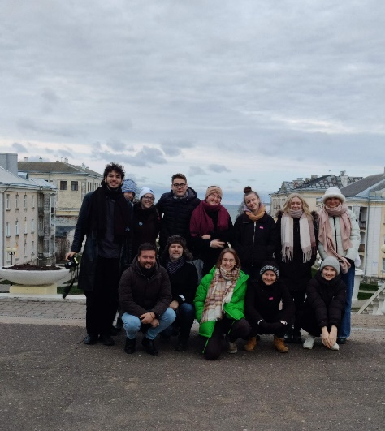

19th of November- Saturday

This was the day of our trip back to Hungary. We felt sorrow as we had to leave the wonderful people we had met and the magnificent country of Estonia. Our bus left Tartu at 9 o’clock and arrived in Tallinn around half past 11. We had some time to shop and relax before our flight departed to Warsaw. Our flight from Warsaw to Budapest was delayed a bit but fortunately, we landed in Budapest at around 6 o’clock where our family members warmly welcomed us. The experience we had in Estonia is invaluable and we are looking forward to the next chapter of cooperation with our Estonian friends in Budapest.